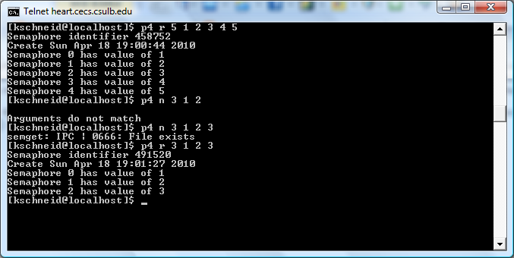

1. P4 r 5 1 2 3 4 5 – This checks for an existing semaphore set. The semaphore does not currently exist and the program creates a new semaphore.
2. P4 n 3 1 2 – The number of semaphores in the set is 3, however 2 values are given, thus the arguments do not match.
3. P4 n 3 1 2 3 – Since the not remove option was selected and semaphore set already exist, the program displays the error message that the file already exists.
4. P4 r 3 1 2 3 – This checks for an existing semaphore set. The set already exist, but since the remove option was selected, the semaphore is removed and a new set is created.